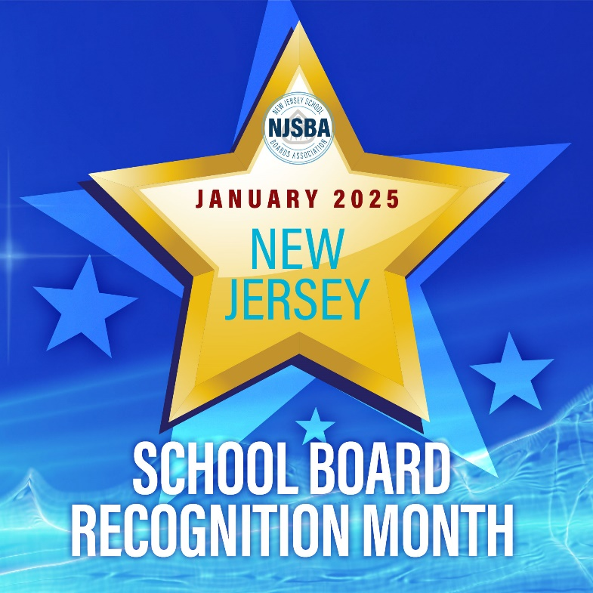

Certificate of Appreciation

Presented by

[Enter name of presenting organization here]

To

[Enter name of school board member here]

of the

[Enter name of board of education here]

In Recognition of
Dedicated Service to the

Schoolchildren of our Community
---
Presented During

School Board Recognition Month
January 2025

