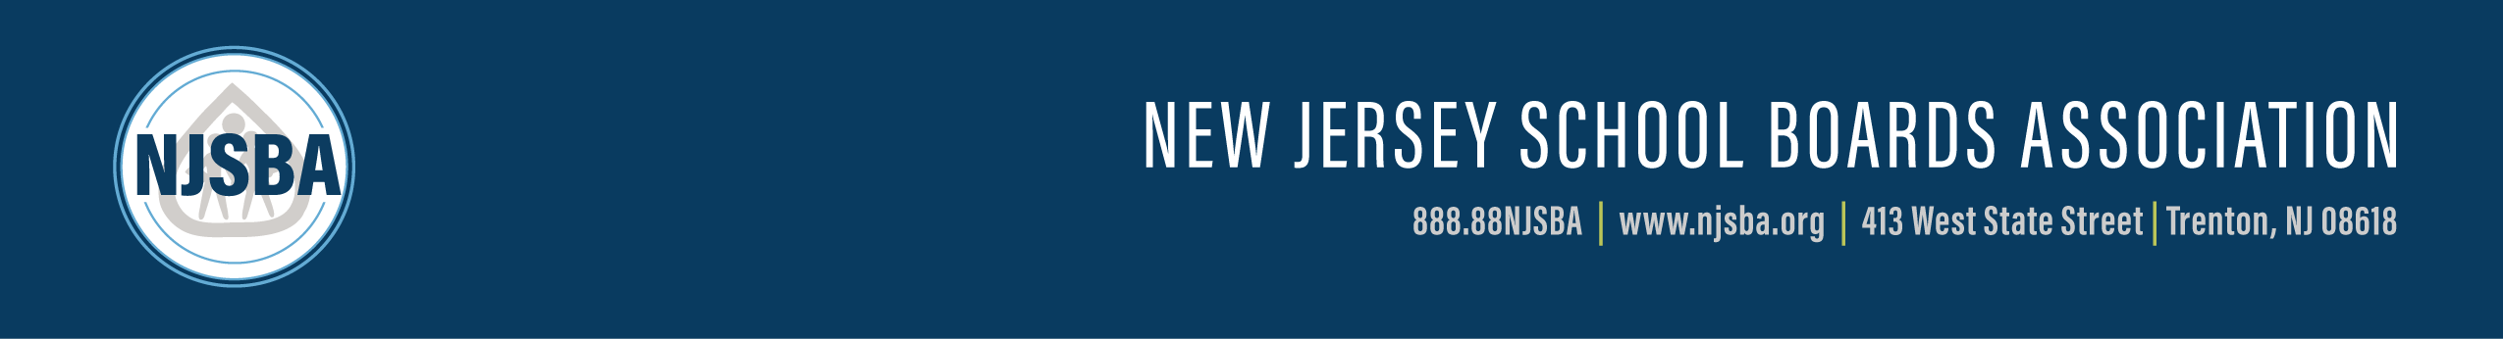

Please supply complete information as requested in all categories (**Must be printed in ink, typed or computer generated**. Additional sheets may be used if necessary.)

**DEADLINE:** January 17, 2025 Karen Cortellino, M.D., President

(By 5:00 p.m.) Irene LeFebvre, Chairperson

NOMINATING COMMITTEE

ATTN: Cynthia J. Harrison

NEW JERSEY SCHOOL BOARDS ASSOCIATION

413 West State Street, NJ 08618

**INTERVIEW DATES:** February 7, 2025 at 9:00 p.m.

(***Please save the dates***) February 14, 2025 at 9:00 a.m.

**(If Necessary)** February 15, 2025 at 9:00 p.m.

***Applications may be mailed: return receipt requested OR e-mailed (charrison@njsba.org).***

***Applicants must have completed one full three-year term as a board member prior to his/her election to NJSBA office.***

As per Nominating Committee procedures, applicants may apply for only one officer position.

I am applying for the position of: President

* Vice President for County Activities
* Vice President for Finance
* Vice President for Legislation/Resolutions

Name

(first) (middle) (last)

Home Address: Street

City State Zip + 4

Phone: Home: ( ) Office: ( )

Board Type of Board

County Length of Service on Board Term Expiration

Local Board Positions/Committees and dates of service

County Level Positions/Committees and dates of service______________________________________

___________________________________________________________________________________

___________________________________________________________________________________

State Level Positions/Committees and dates of service

Education

Current Employment

Qualifications/Interest for the office for which you have applied

**Signature**

If you wish to expand on any of these items, continue below or use additional sheet.