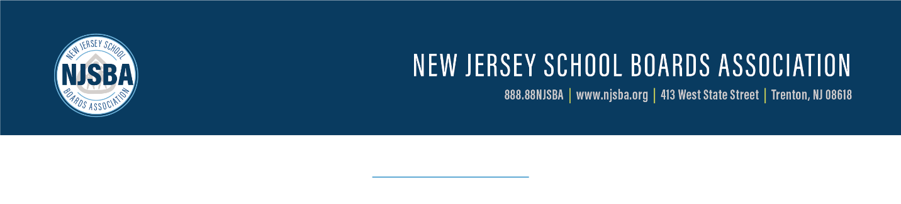

NEWS RELEASE

CONTACT: | Janet Bamford (jbamford@njsba.org)  (609) 278-5247 | FOR IMMEDIATE RELEASE
Thomas Parmalee (tparmalee@njsba.org)
(609) 278-5251
Voters Approve Construction Questions in Special Election
TRENTON, Dec. 12, 2024 - On Dec. 10, voters headed to the polls for a special school district election, approving construction questions submitted by two school districts.
Statewide bonding amount approved: $84,870,133.
State funding to be provided: $22,508,213.60.
Under the Educational Facilities and Construction and Financing Act of 2000, the state will fund at least 40% of eligible school construction costs through annual debt service aid.
The below results are not yet certified and are unofficial.
Burlington County
Burlington Township: The board of education had two proposals on the ballot, both of which were approved by voters.
Proposal one – APPROVED – The board is seeking authorization to a.) undertake for lawful school purposes a capital improvement program consisting of: 1.) various renovations, upgrades and site improvements at the Burlington Township High School and Annex, together with the completion of various other improvements, including renovations to student locker rooms, restrooms, science classrooms and guidance suite, roof replacements, parking lot improvements, upgrades to HVAC systems, renovations to the school cafeteria and locker rooms in the Annex building, and other related site work at the Burlington Township High School; 2.) various renovations, upgrades and site improvements at the Burlington Township Middle School, including the partial replacement of the roof, improvements to parking areas and driveways, site and drainage improvements, and related site work; 3.) various renovations, upgrades and site improvements at the Fountain Woods Elementary School, together with the completion of various other improvements, including HVAC system improvements, improvements to parking areas and driveways, and other related site work; 4.) various renovations and upgrades to classrooms at the B. Bernice Young Elementary School, together with the completion of various other improvements, including HVAC system improvements, and other related site work; and 5) the completion of such other work and improvements, and acquisition of furniture, fixtures and equipment as may be necessary therefor or related to the completion of the projects set forth above; b.) expend for all the foregoing an amount not to exceed $27,454,265 (all of which represents eligible costs), as determined by the commissioner of education); and c.) issue bonds of the school district for said project in an amount not to exceed $27,454,265 in which event the state will pay approximately 40% of the debt service (principal and interest) of the school bonds issued to finance the final eligible costs.
Bonding amount approved: $27,454,265.
State funding: $10,981,706.
Proposal two – APPROVED – This proposal will only take effect if proposal one is also approved by voters, as is indicated by unofficial results.
In this proposal, the board of education is seeking authorization to a) undertake for lawful school purposes, a capital improvement program consisting of: 1.) various renovations, upgrades and site improvements to the athletic facilities at Burlington Township High School athletic fields, together with the completion of various other improvements, including, installation of new synthetic turf, site and drainage improvements, bleacher and fencing repairs, installation of new scoreboards, track improvements, and other related site work; and 2.) various site improvements to the Fountain Woods Elementary School athletic fields, including installation of new synthetic turf, drainage improvements, installation of a new scoreboard, and associated improvements necessary heretofore or related thereto; and 3.) the completion of such other work and improvements, including the acquisition of fixtures and equipment as may be necessary therefor or related to the projects set forth above; b.) expend for all the foregoing an amount not to exceed $10,723,783 ($2,319,000 of which represents eligible costs as determined by the commissioner of education); c.) issue bonds of the school district for said project in an amount not to exceed $10,723,783, in which event the state will pay approximately 40% of the debt service (principal and interest) of the school bonds issued to finance the final eligible costs. This school facilities project includes $8,404,783 for school facility construction elements in addition to the facility efficiency standards developed by the commissioner of education or that are not otherwise eligible for state support pursuant to N.J.S.A. 18A:7G-5(g).
Bonding amount approved: $10,723,783.
State funding: $927,600.
Camden County
Haddonfield – APPROVED – The board of education is seeking authorization to a.) undertake various improvements, alterations, renovations and upgrades to Central Elementary School, Haddonfield Middle School, and Haddonfield Memorial High School, including the acquisition and installation of fixtures, furniture, equipment and any site work; b.) undertake various improvements, alterations, renovations and upgrades, and the construction of additions to Elizabeth Haddon Elementary School and J. Fithian Tatem Elementary School, including acquisition and installation of fixtures, furniture, equipment and any site work; c.) undertake the relocation and restoration of the existing historic Maggie House and Carriage House to accommodate the construction of a gymnasium and parking lot for the Hopkins Athletic Complex, including acquisition and installation of fixtures, furniture, equipment and any site work; d.) appropriate $46,692,085 for such improvements; and (e) issue bonds in an amount not to exceed $46,692,085.
The final eligible costs for the projects approved by the New Jersey commissioner of education are $26,497,269 (consisting of $3,633,501 for Central Elementary School, $3,831,877 for Haddonfield Middle School, $9,466,775 for Haddonfield Memorial High School, $6,262,694 for Elizabeth Haddon Elementary School, $3,302,422 for J. Fithian Tatem Elementary School and $0 for Hopkins Athletic Complex). The projects include $2,654,321 (consisting of $161,000 for Central Elementary School, $69,000 for Haddonfield Middle School, $399,504 for Haddonfield Memorial High School, $195,000 for Elizabeth Haddon Elementary School, $0 for J. Fithian Tatem Elementary School and $1,829,817 for the Hopkins Athletic Complex) for school facility construction elements in addition to the facilities efficiency standards developed by the commissioner of education or not otherwise eligible for state support pursuant to N.J.S.A. 18A:7G-5(g). The state debt service aid percentage will equal 40% of the annual debt service due with respect to the final eligible costs of the projects.
Bonding amount approved: $46,692,085.
State funding: $10,598,907.60.
Historical information on annual school elections and school construction proposals in New Jersey is available on the NJSBA website.
_____________________________________________________________________
The New Jersey School Boards Association, a federation of district boards of education, advocates the interests of school districts, trains local school board members, and provides resources for the advancement of public education.

